Get Terms Details For A User API
Verification Guide

Revision History
Author | Revision Number | Date
TCSCODER | 1.0 | 2016-07-27

Contents

Contents 2
Deployment Instructions 3
Organization of Submission 3
Application Setup 3
Verification 4
Resource Contact List 10

Deployment Instructions

Organization of Submission

/doc/ – documentation;
/doc/Verification_Guide-Get Terms Details For A User API.doc – this file;
/patch/ – git patch;
/patch/submission.patch – the patch file of the submission;
/postman/ - Postman files to test the submission;
/postman/Challenge%2030054600.postman_collection.json – the collection to be imported into Postman;
/postman/Challenge%2030054600.postman_environment.json – the environment

Application Setup

Docker setup

Please refer to https://github.com/appirio-tech/tc-common-tutorials/tree/master/docker/informix. Updating the docker with latest scripts is not required.

API setup

The deployment of the API is documented at https://github.com/appirio-tech/tc-api/wiki. Follow it, but in addition the following:

Node.js version

The Node.js version is not mentioned at those pages, but the API is intended to work on version 0.10.xx, not on later ones. If you use later version and don't want to downgrade, problems may occur.

Applying the patch

Apply the supplied patch right after downloading the API with git clone. If git is accessible in command line in your system, it's done with the following command:

git apply (path to submission)/patch/submission.patch

in the tc-api directory.

The bridge

The API doesn't work without an external HTTP service that listens on port 8082 and executes SQL queries. The submission contains a simple script that works (probably) just like the service the API needs. To run it, execute

node test/scripts/bridge &

in the tc-api directory right before npm start but after running deploy/development.sh script.

Verification

Verification of the new code with JSLint

Install JSLint with
sudo npm install jslint -g
(npm install jslint -g without sudo in Windows)

Run the following commands it the tc-api directory:
jslint --nomen actions/terms.js
jslint --nomen test/scripts/bridge.js
jslint --nomen test/scripts/getTermsForUser/cleanData.js
jslint --nomen test/scripts/getTermsForUser/insertData.js
jslint --nomen routes.js
jslint --nomen test/test.termsOfUse.js
Each of these command should report “(file) is OK”.

Verification of apiary.apib with https://apiary.io site

Go to https://apiary.io.

If you already have an account at this site, sign in and create new API.

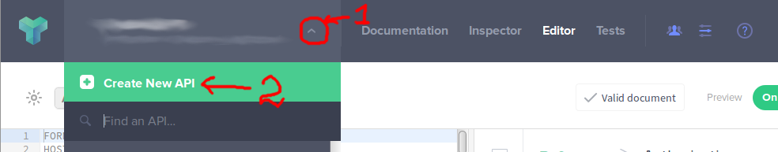

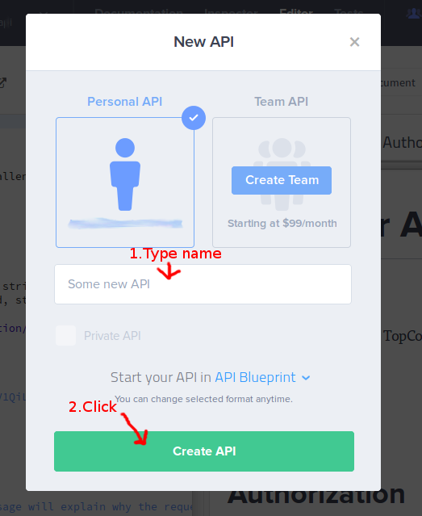

If you don't have an account, sign up, choose free plan, and you'll be prompted to create an API.

Anyway, you'll appear in the API editor:
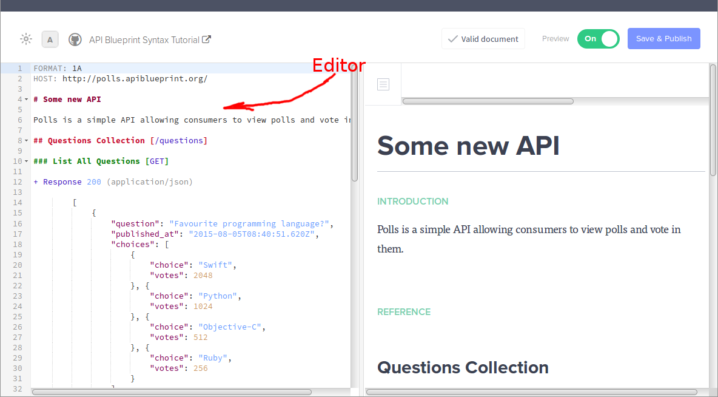

Delete all the text in the editor (Ctrl-A Ctrl-X) and copy/paste the entire text from the apiary.apib file. In the top-right part of the page you'll see that the text is being validated:

After several seconds you'll see this:


Click “Save & Publish” at the top-right corner of the page. Wait until the text of the button change to “Published!”. Then click “Documentation” in the top navigation menu.

You'll see the page consisting of three columns.
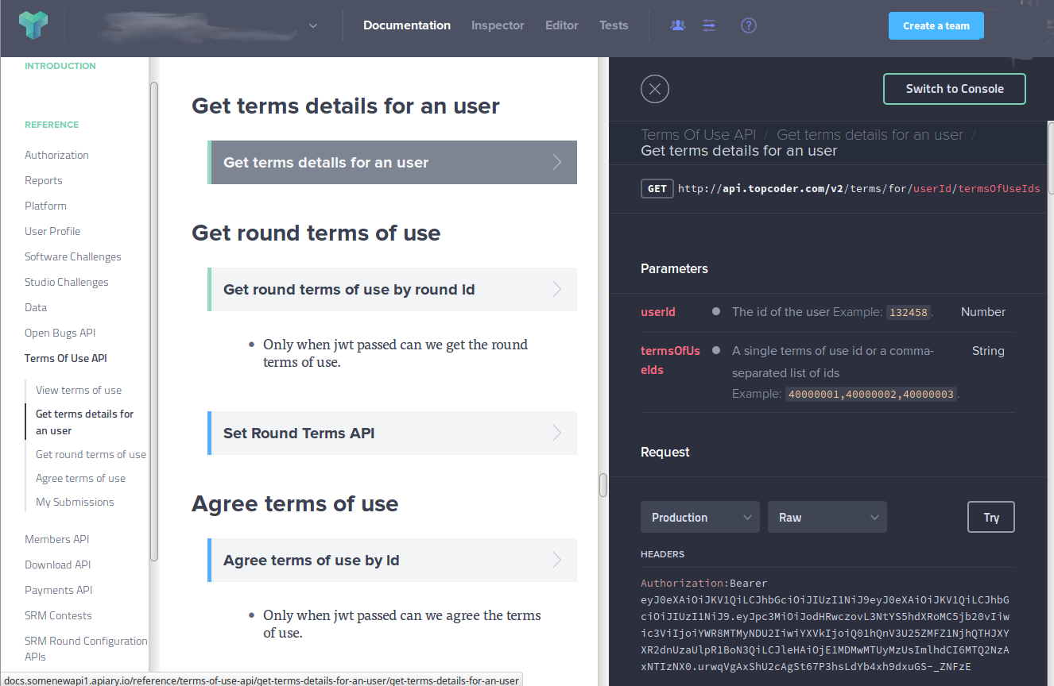

In the left column find and click “Terms Of Use API”, then “Get trams details for an user”.
In the sentral column click “Get terms details for an user” (where it's gray on the picture).
In the right column you'll see the details of the action.

Verification of the service with unit test

Open the shell (command line) and go to the tc-api directory. Set up the environment variables like it's described at https://github.com/appirio-tech/tc-api/wiki (JAVA_HOME, PATH (in Windows) and deploy/development.sh).

Run
node_modules/.bin/mocha --grep "Get Terms Details For A User API" ./test

There are 6 tests for this service. All of them should pass.

Verification of the service with Postman

Preparing data in the database

Open the shell (command line) and go to the tc-api directory. Set up the environment variables like it's described at https://github.com/appirio-tech/tc-api/wiki (JAVA_HOME, PATH (in Windows) and deploy/development.sh).

Run
node test/scripts/getTermsForUser/insertData.js

After you finish with Postman, run
node test/scripts/getTermsForUser/cleanData.js

The tests below rely on some data that are already present in the database (there are these data in the database provided in Docker). Tests assume that there is an user with handle “heffan” and id 132456 which is an admin and an user with handle “user” and id 132458 which is not an admin.

Running tests in Postman

Run Postman.

Click “Import” at the top left of the Postman window

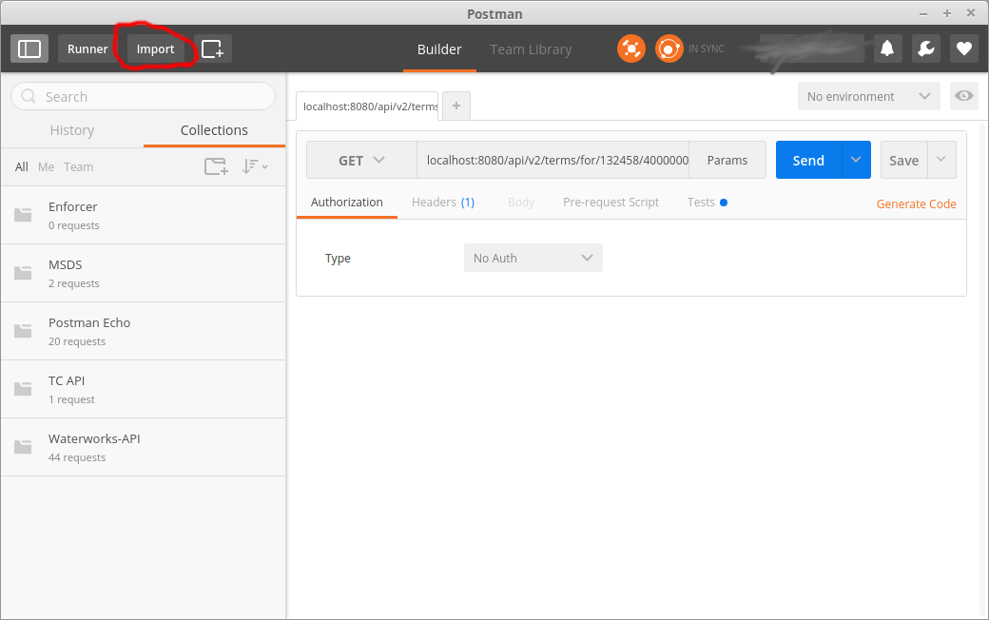
Click “Choose Files” and select 2 files from the test/postman/ directory of the tc-api.

Choose an environment called “Challenge 30054600”
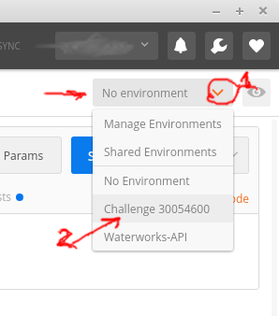

In the collection also called “Challenge 30054600” you can see 8 request, each has a number from 1 to 8. Try to execute them one by one and see results.
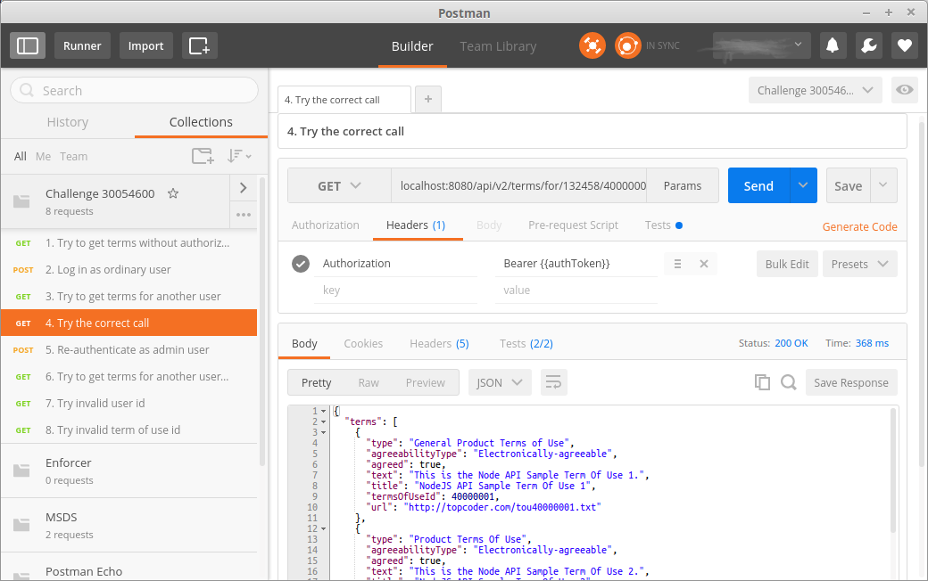

Pay attentions to tests provided in these requests:
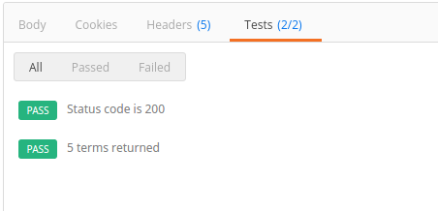
If everything's correct, all tests in all requests must pass.

Here are the descriptions of all 8 tests:

1. Try to get terms without authorization

The API rejects a request if it doesn't contain authorization token. This request demonstrates it.

2. Log in as ordinary user

This request uses the /auth call to get the auth token. On success the token obtained is stored in the environment.

3. Try to get terms for another user

Unlike the request 1, this request contains the authorization token (which is taken from the environment). The user authenticated in request 2 is not an admin, so he cannot get the data for any user id except his own.

4. Try the correct call

This call is different from request 1 only by the user id in the URI. Now it's the URI of the user which authenticated in request 2. Should return the data.

5. Re-authenticate as admin user

Switch to the user with admin rights. Update the auth token in the environment.

6. Try to get terms for another user again

Just the same as request 4, but now the auth token belongs to another user. Demonstrates that an admin can get the data for any user id.

7. Try invalid user id

Demonstrates how the API detects the invalid user id and how does it respond in this case.

8. Try invalid term of use id

Demonstrates the behavior in the case of bad terms of use Ids syntax.

Resource Contact List
Name | Resource Email
TCSCODER

